|  |  |  |
| --- | --- | --- |
| Functional(F)/Non-functional(NF) | Requirements | MoSCoW |
| NF(R1) | Login | M |
| NF(R2) | Registration | M |
| F(R3) | Admission Process | M |
| F(R4) | Update Information | S |
| F(R5) | Delete Information | C |
| F(R6) | Retrieve Information | S |
| F(R7) | Create Information | S |
| NF(R8) | Fees Information | S |
| NF(R9) | Teacher Information | S |
| NF(R10) | Student Information | M |
| F(R11) | Routines | M |
| F(R12) | Results | M |
| F(R13) | Laboratory | M |
| F(R14) | Salary | M |
| NF(R15) | Calendar | S |

Functional and Non-functional Requirements of School Management System

UI Design for School Management System

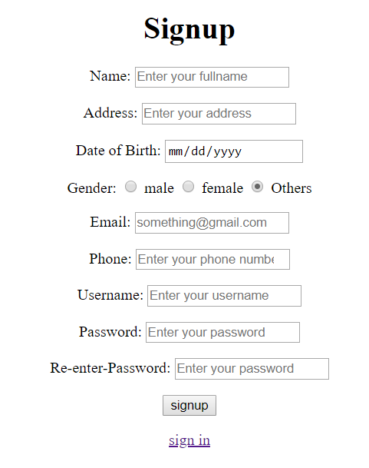

Fig: Registration Form

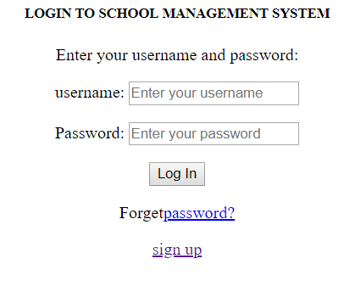

Fig: login form

Initial class diagram for school management system

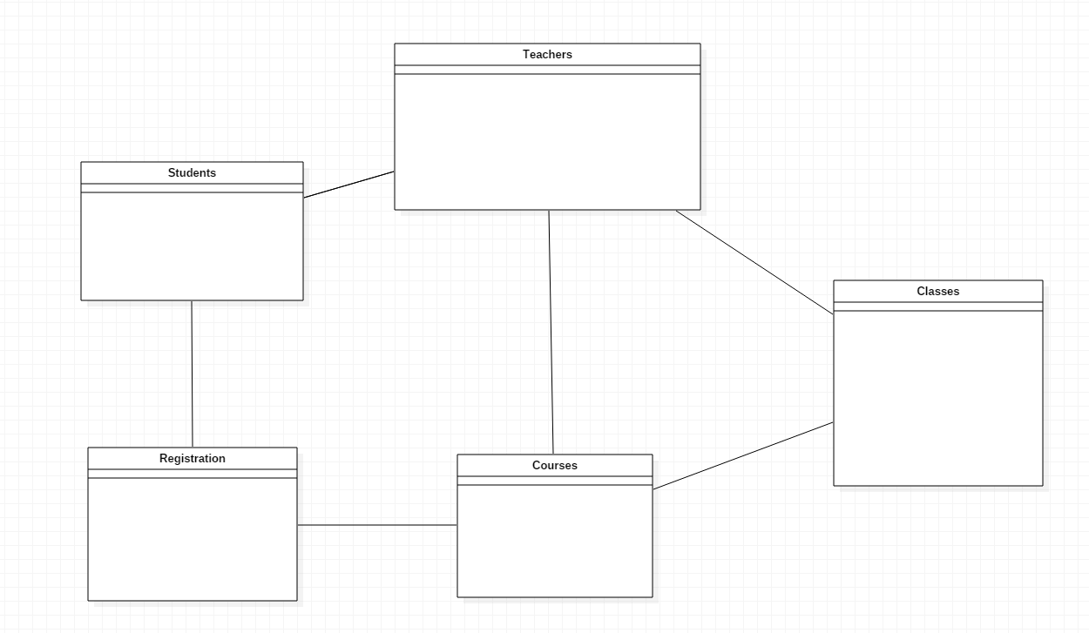

Use case diagram for school management system

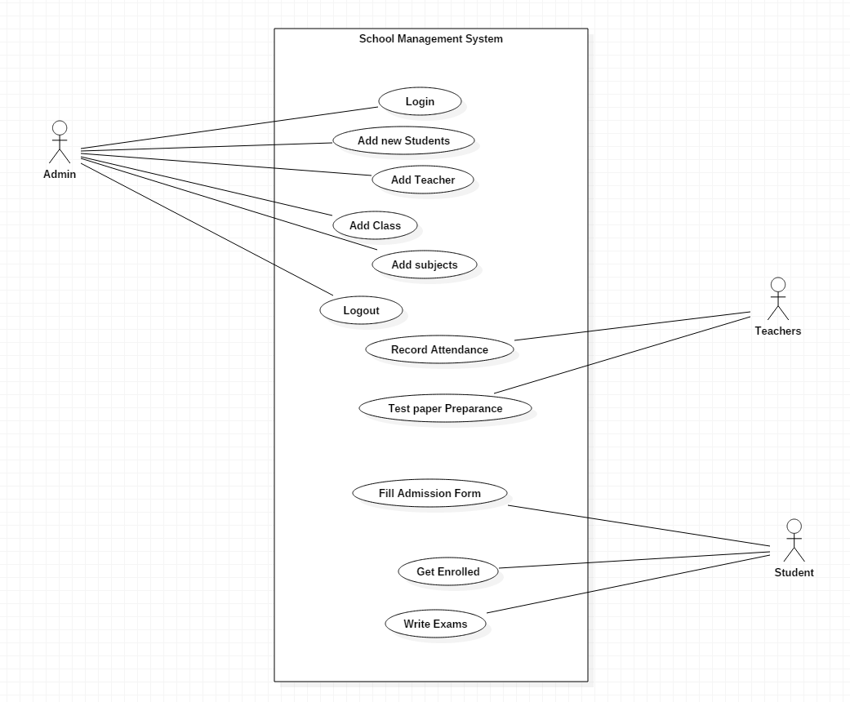

ER diagram for school management system

